### 

### Semester One Examination, 2021

### Question/Answer booklet

# MATHEMATICS METHODS

**UNIT 3**

## Section One:

## Calculator-free

|  |  |
| --- | --- |
| **Your Name:** |  |
| **Your Teacher’s Name:** |  |

## Time allowed for this section

Reading time before commencing work: five minutes

Working time: fifty minutes

## Materials required/recommended for this section

***To be provided by the supervisor***

This Question/Answer booklet

Formula sheet

***To be provided by the candidate***

Standard items: pens (blue/black preferred), pencils (including coloured), sharpener, correction fluid/tape, eraser, ruler, highlighters

Special items: nil

## Important note to candidates

No other items may be taken into the examination room. It is **your** responsibility to ensure that you do not have any unauthorised material. If you have any unauthorised material with you, hand it to the supervisor **before** reading any further.

|  |  |  |  |  |  |
| --- | --- | --- | --- | --- | --- |
| Question | Marks | Max | Question | Mark | Max |
| 1 |  | 6 | 5 |  | 8 |
| 2 |  | 9 | 6 |  | 6 |
| 3 |  | 4 | 7 |  | 5 |
| 4 |  | 12 |  |  |  |

**Structure of this paper**

|  |  |  |  |  |  |
| --- | --- | --- | --- | --- | --- |
| Section | Number of questions available | Number of questions to be answered | Working time (minutes) | Marks available | Percentage of examination |
| Section One:  Calculator-free | 7 | 7 | 50 | 50 | 34 |
| Section Two:  Calculator-assumed | 12 | 12 | 100 | 96 | 66 |
|  |  |  |  | **Total** | 100 |

**Instructions to candidates**

1. The rules for the conduct of the Western Australian Certificate of Education ATAR course examinations are detailed in the *Year 12 Information Handbook 2019*. Sitting this examination implies that you agree to abide by these rules.
2. Write your answers in this Question/Answer booklet.
3. You must be careful to confine your answers to the specific questions asked and to follow any instructions that are specific to a particular question.
4. Additional pages for the use of planning your answer to a question or continuing your answer to a question have been provided at the end of this Question/Answer booklet. If you use the space to continue an answer, indicate in the original answer space where the answer is continued, i.e. give the page number.
5. **Show all your working clearly.**Your working should be in sufficient detail to allow your answers to be checked readily and for marks to be awarded for reasoning. Incorrect answers given without supporting reasoning cannot be allocated any marks. For any question or part question worth more than two marks, valid working or justification is required to receive full marks. If you repeat any question, ensure that you cancel the answer you do not wish to have marked.
6. It is recommended that you **do not use pencil**, except in diagrams.
7. The Formula sheet is **not** to be handed in with your Question/Answer booklet.

**Section One: Calculator-free (50 Marks)**

This section has **seven** questions. Answer **all** questions. Write your answers in the spaces provided.

Spare pages are included at the end of this booklet. They can be used for planning your responses and/or as additional space if required to continue an answer.

● Planning: If you use the spare pages for planning, indicate this clearly at the top of the page.

● Continuing an answer: If you need to use the space to continue an answer, indicate in the original answer space where the answer is continued, i.e. give the page number. Fill in the number of the question that you are continuing to answer at the top of the page.

Working time: 50 minutes.

**Question 1 (6 marks)**

The total cost $C\left(x\right)$ of a company producing $x$ LCD digital alarm clocks is calculated based on a fixed cost of $16 plus individual clock cost of $6.

(a) Determine the **average** cost function $A\left(x\right)=\frac{C\left(x\right)}{x}$ . (2 marks)

$$A\left(x\right)=\frac{16+6x}{x}=\frac{16}{x}+6$$

* Determine the correct expression for the total cost
* Determine the correct expression for the average cost (No need to simplify)

(b) Determine an expression for $A^{'}\left(x\right).$ (2 marks)

$$A^{'}\left(x\right)=-\frac{16}{x^{2}}$$

* Demonstrate the use of quotient rule
* Determine the correct expression

(c) Evaluate the marginal average cost for producing 20 alarm clocks. (2 marks)

$$A'\left(20\right)=-\frac{16}{{20}^{2}}=\$-0.04=-4 cents$$

* Recognise the marginal average cost is $A'(x)$
* Determine the correct answer

**Question 2 (9 marks)**

1. Given that $f(x)=x^{3}g(x)$ , $g\left(-1\right)=2, g'(-1)=-9,$  determine the value of $f'(-1)$

(3 marks)

$$f^{'}\left(x\right)=3x^{2}g\left(x\right)+x^{3}g^{'}\left(x\right)$$

$$f^{'}\left(-1\right)=3{\left(-1\right)}^{2}g\left(-1\right)+{\left(-1\right)}^{3}g^{'\left(-1\right)}$$

$$=3\left(1\right)\left(2\right)+\left(-1\right)\left(-9\right)$$

$$=6+9=15$$

* Demonstrate the use of product rule
* Substitute correct values
* Determine the correct answer

1. Determine the gradient of the tangent line to $p\left(x\right)=9 cos(x)$  at $x=π$ . (3 marks)

$$p^{'}\left(x\right)=9 sin⁡(x)$$

$$p^{'}\left(π\right)=9\sin\left(π\right)=0$$

* Determine the correct $p'(x)$
* Substitute correct exact values
* Determine the correct gradient

1. At , (), on the graph of $q(x)=x^{3}$ , the tangent line has an $x$  intercept of $\left(\frac{2}{3}, 0\right).$ Determine the value of . (3 marks)

$$q^{'}\left(x\right)=3x^{2}=3a^{2}$$

$$\frac{a^{3}-0}{a-\frac{2}{3}}=3a^{2}$$

$$a^{3}=3a^{2}\left(a-\frac{2}{3}\right)$$

$$a^{3}=3a^{3}-2a^{2}$$

$$2a^{3}-2a^{2}=0,$$

$$2a^{2}(a-1)=0$$

$$a=0 \left(reject\right), 1$$

$$a=1$$

* Determine the correct gradient function $q'(x)$
* Use $(\frac{2}{3}, 0)$ to determine the equation of the tangent line in terms of $a$.
* Solve for the correct $a$.

**Question 3 (4 marks)**

Determine the **exact** area of the region bounded by and the $y$ -axis.

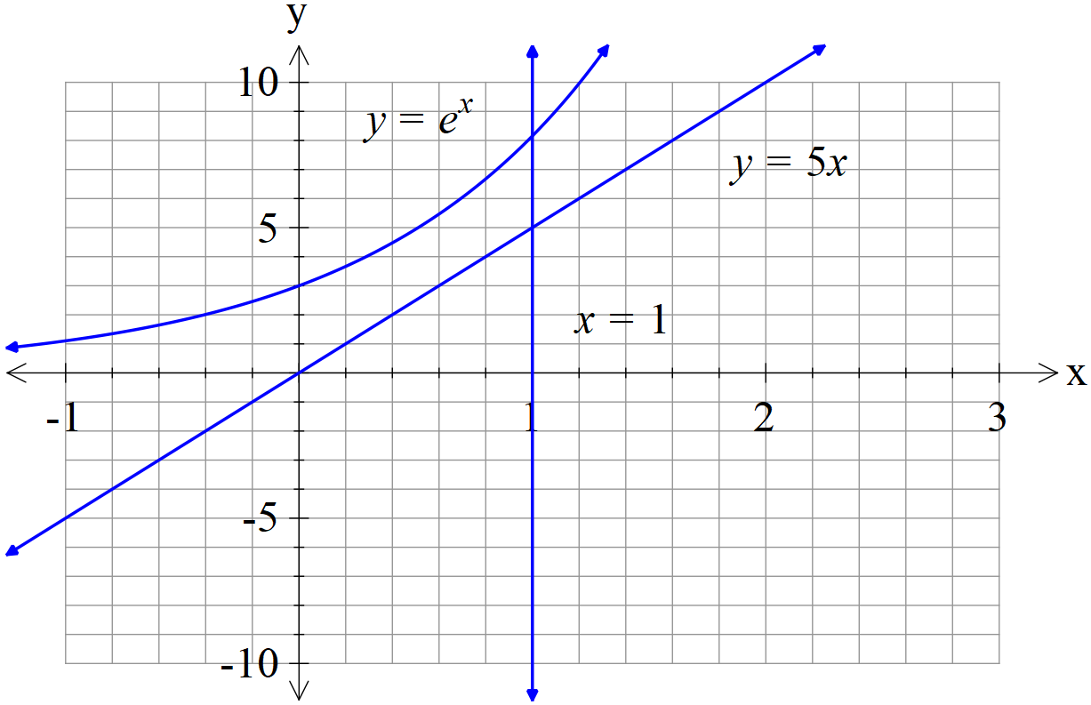

$$\int_{0}^{1}{e^{x}-5x}dx$$

$$={\left(e^{x}-\frac{5x^{2}}{2}\right)|}_{0}^{1}$$

$$=\left(e-\frac{5}{2}\right)-(1-0)$$

$$=e-\frac{7}{2}$$

* Set up the correct integral using difference of the functions
* Set up the correct integral with correct boundaries
* Determine the correct antiderivative
* Determine the correct area

**Question 4 (12 marks)**

The discrete random variable X has probability distribution given by the following table

|  |  |  |  |  |
| --- | --- | --- | --- | --- |
| $$x$$ | $$1$$ | $$2$$ | $$3$$ | $$4$$ |
| $$P(X=x)$$ | $$4k$$ | $$3k$$ | $$2k$$ | $$k$$ |

Where $k$ is a constant.

(a) Determine the value of $k.$ (2 marks)

$$10k=1,$$

$$k=\frac{1}{10}$$

* Use the sum of probability equals 1
* Calculate the correct $k$ (2 marks)

(b) Determine the value for $E(X)$. (2 marks)

$$E\left(X\right)=1×\frac{4}{10}+2×\frac{3}{10}+3×\frac{2}{10}+4×\frac{1}{10}=2$$

* Set up the equation for $E\left(X\right)$
* Calculate the correct $E(X)$ (2 marks)

(c) Determine $Var\left(X\right).$ (3 marks)

$$Var\left(X\right)={\left(1-2\right)}^{2}\left(\frac{4}{10}\right)+{\left(2-2\right)}^{2}\left(\frac{3}{10}\right)+{\left(3-2\right)}^{2}\left(\frac{2}{10}\right)+{\left(4-2\right)}^{2}\left(\frac{1}{10}\right)=1$$

* Set up the equation for $Var\left(X\right)$
* Calculate the correct variance (2 marks)

Another random variable $Y=6-2X$

(d) Determine $Var\left(Y\right).$ (2 marks)

$$Var\left(Y\right)=2^{2}\left(1\right)=4$$

* Use the square of 2
* Calculate the correct variance

(e) Calculate $P(X≥Y)$. (3 marks)

$$X≥6-2X, X≥2$$

$$P\left(X≥2\right)=1-P\left(X=1\right)=1-\frac{4}{10}=\frac{6}{10}$$

* Covert to $P(X≥2)$
* Calculate the correct probability (2 marks)

**Question 5 (8 marks)**

A particle moves in a straight line for two seconds with a constant acceleration $2m/s^{2}$ and an initial velocity of $-2 m/s$ starting from the origin. That is $a\left(t\right)=2m/s^{2}$ and $v_{0}=-2m/s.$

(a) Determine when the particle is at rest. (2 marks)

$$v\left(t\right)= -2 + 2t=0$$

$$t=1s$$

* Determine the correct expression for $v\left(t\right)$
* Equate $v\left(t\right)$ to zero and solve the correct answer for $t$

(b) Determine the displacement from the origin of the particle at the end of the two seconds. (3 marks)

$$\int_{0}^{2}{-2+2t dt={\left[-2t+t^{2}\right]}_{0}^{2}=0}$$

* Set up the correct integral with correct boundaries
* Determine the correct antiderivative
* Determine the correct displacement

(c) Determine the distance travelled by the particle during the two seconds. (3 marks)

$$\int_{0}^{2}{\left|-2+2t\right|dt=\int_{0}^{1}{-2+2t dt+\int_{1}^{2}{2-2t dt={(-2t+t^{2})}_{0}^{1}}}}+{(2t-t^{2})}_{1}^{2}=2m$$

* Set up the correct integral in two parts
* Set up the correct integral in two parts with correct boundaries
* Determine the correct distance (no units required)

**Question 6 (6 marks)**

The graph of the cubic function $f (x) = ax^{3} + bx^{2} + cx + d$ is shown below. The function has two turning points at $x=-\frac{1}{3}$ and $x=1$. The function also has a point of inflection at $x=\frac{1}{3}$.

Determine the values of $a, b, c$ and $d.$

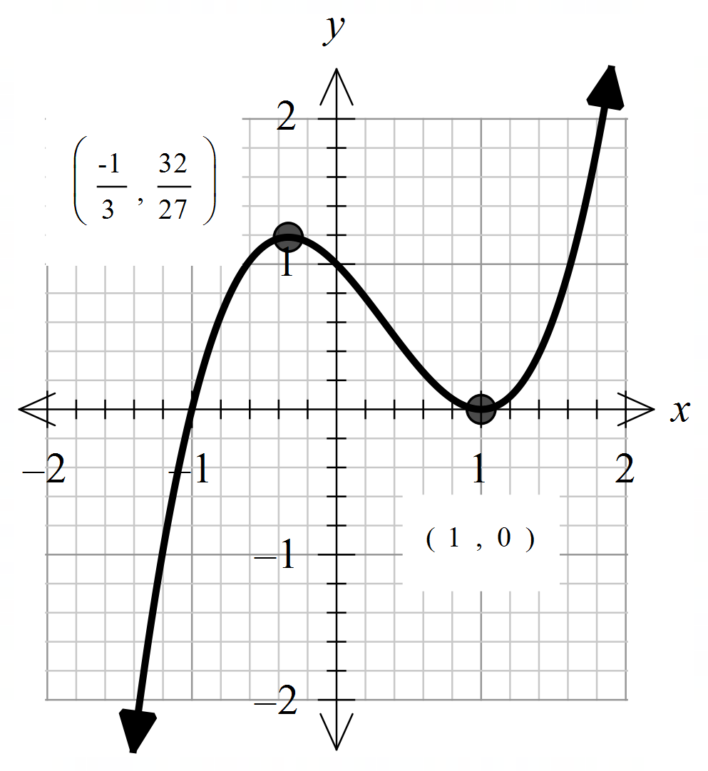

$$f^{'}\left(x\right)=3ax^{2}+2bx+c, f^{'}\left(-\frac{1}{3}\right)=f^{'}\left(1\right)=0$$

$$f^{''}\left(x\right)=6ax+2b, f^{''}\left(\frac{1}{3}\right)=0$$

$$f\left(1\right)=0 and f\left(-\frac{1}{3}\right)=\frac{32}{27}$$

$$\left\{\begin{aligned}3a{\left(-\frac{1}{3}\right)}^{2}+2b(-\frac{1}{3})+c=0 \\ 3a{\left(1\right)}^{2}+2b\left(1\right)+c=0 \\ 6a\left(\frac{1}{3}\right)+2b=0 \\ a+b+c+d=0 \\ \left(-\frac{1}{27}\right)a+\frac{1}{9}b-\frac{1}{3}c+d=\frac{32}{27}\end{aligned}\right.$$

$$\left\{\begin{aligned}\frac{1}{3}a-\frac{2}{3}b+c=0 \\ 3a+2b+c=0 \\ a+b=0 \\ a+b+c+d=0 \\ -a+3b-9c+27d=32\end{aligned}\right.$$

$$a=1, b=-1, c=-1, d=1$$

* State the first and second derivative of $f(x)$
* Recognise $f^{''}\left(\frac{1}{3}\right)=0$ and hence determine the correct expression for $a \& b$
* Recognise $f^{'}\left(1\right)=f'(-\frac{1}{3})=0$ and hence determine the correct expression for $a, b \& c$
* Recognise $f\left(-\frac{1}{3}\right)=\frac{32}{27}$ and $f\left(1\right)=0$ and hence determine the correct expression for $a, b, c \& d.$
* Determine one correct value
* Determine all correct values

**Question 7 (5 marks)**

Given a point $P(1, 2)$  in the first quadrant of the Cartesian plane. A straight line $BA$ is drawn such that it passes through a given point $P,$ and intersects both axes at $A \left(a, 0\right)$ and $B \left(0,b\right),$ where $a$ and $b$ are positive constants. Determine the values for $a$ and $b$ when the triangle $OAB$ has the **smallest** area.

$$P (1, 2)$$

$$A (a, 0)$$

$$B (0, b)$$

$$x$$

$$y$$

$$O$$

$$\frac{b}{2}=\frac{a}{a-1}$$

$$b=\frac{2a}{a-1}$$

$$Area A=\frac{1}{2}ab=\frac{1}{2} a \left(\frac{2a}{a-1}\right)=\frac{a^{2}}{a-1}$$

$$\frac{dA}{da}=\frac{2a\left(a-1\right)-a^{2}}{{\left(a-1\right)}^{2}}=0$$

$$a^{2}-2a=0$$

$$a=0 \left(reject\right) or a=2$$

$$hence b=\frac{2(2)}{2-1}=4$$

$$\frac{d^{2}A}{da^{2}}=\frac{\left(2a-2\right){\left(a-1\right)}^{2}-(a^{2}-2a)2(a-1)}{{\left(a-1\right)}^{4}}>0 when a=2$$

$$Therefore, when a=2, b=4, the triangle reaches minimum area.$$

* Use similar triangles or otherwise determine an expression for $b$ in terms of $a.$
* Determine an expression for area in terms of $a.$
* Determine the first derivative
* Equate the first derivative to 0 and solve for $a$ and $b$
* Use the second derivative or sign test to justify why minimum

Additional working space

Question number: ________

Additional working space

Question number: ________